You will need a Microsoft ID in order to run Visual Studio - you will need to create one if you don’t already have one.

After opening Visual Studio, the screen below appears. Click on **New Project.**

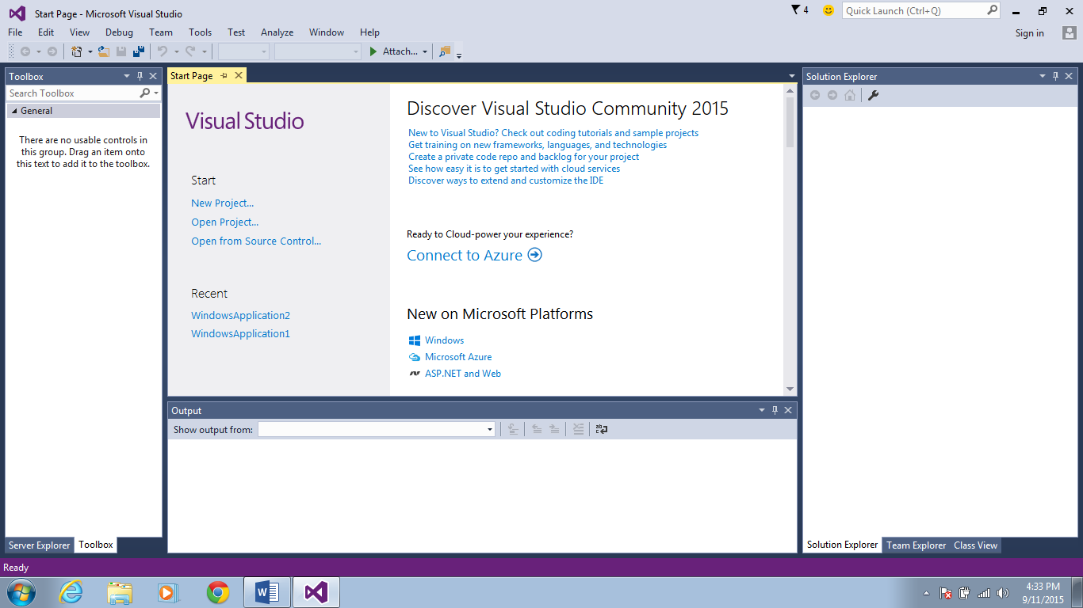

On the left side of the pop up window, click **Installed /templates / Visual Basic**. In the center of the menu, click on **Windows Form Application.** After typing in a name for the project and browsing for the desired location, click on **OK**.

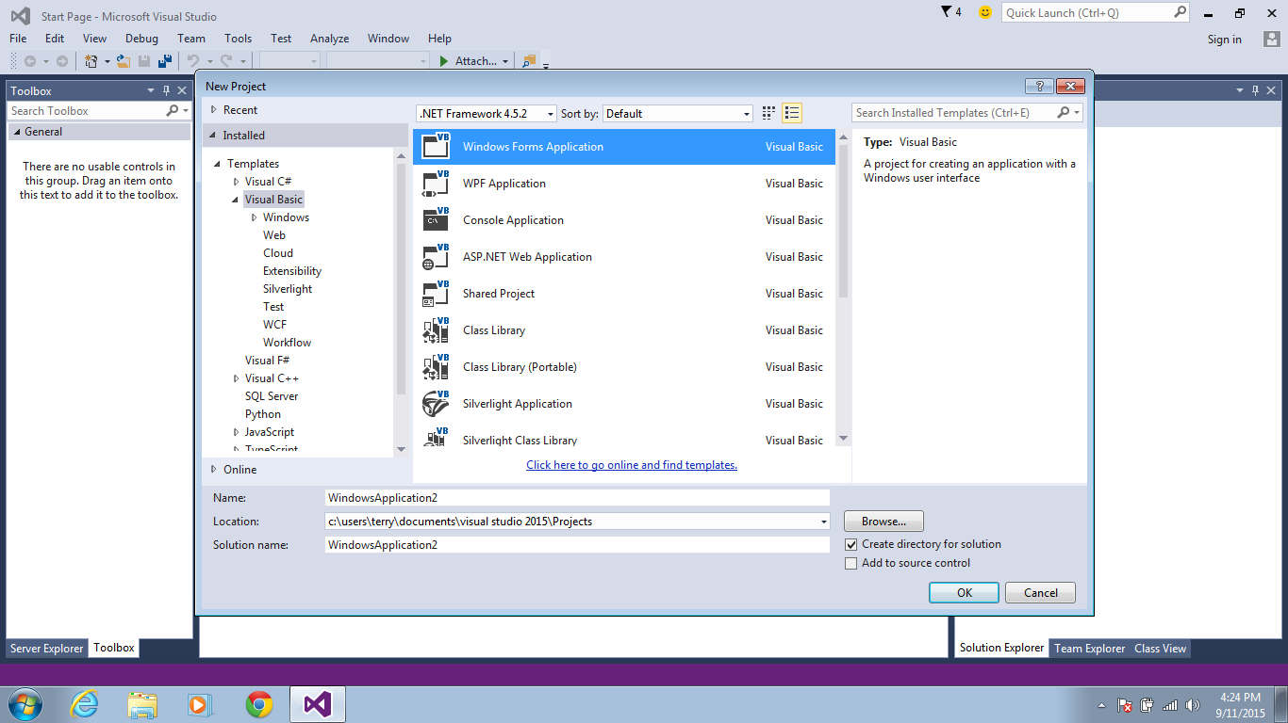

On the left side of the IDE, click the appropriate tabs display the toolbox, click on the icon looking like a push pin to pin the toolbox to the IDE.

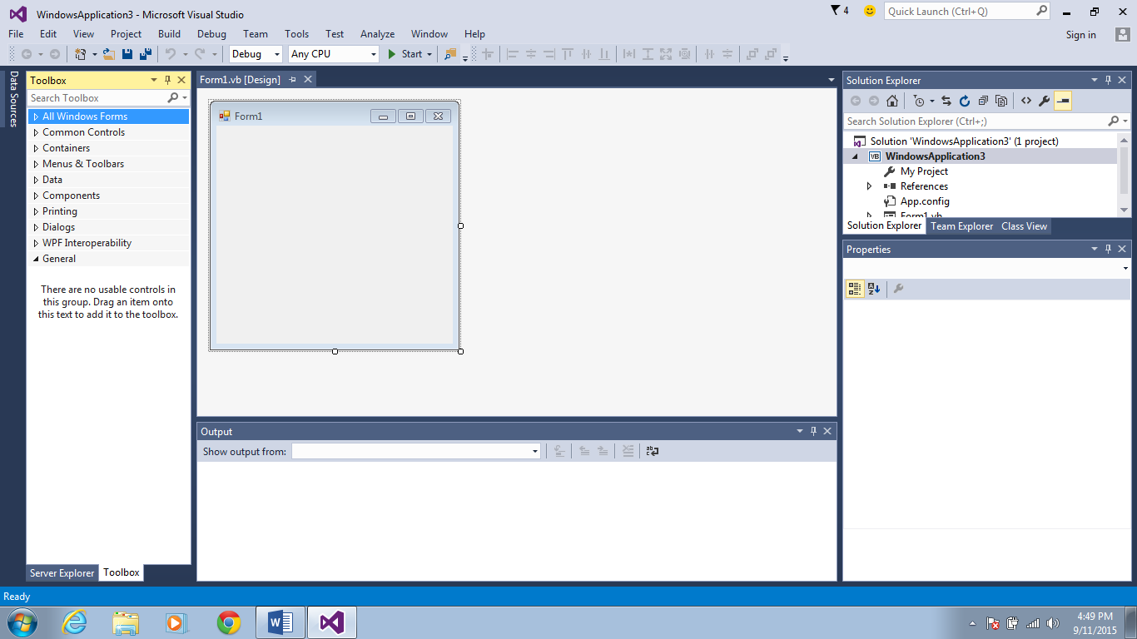

…….and you’re ready to go.

